E-Commerce Trade Cycle
E-Commerce can be applied to all, or different phases of the trade cycle.The trade cycle varies depending on:-
Ø The nature of the organization (or individuals) involved.
Ø The nature and type of goods or services being exchanged.
Ø The frequency of trade between the partners to the exchange process.
The trade cycle has to support:-
- Finding goods or services appropriate to the requirement and agreeing the terms of trade often referred to as search and negotiation.
- Placing the order, taking delivery and making payment i.e., execution & settlement of transaction.
- After sales activity such as warrantee, service etc. There are numerous categories of trade cycles depending on the factors outlined above and, for many transactions, further complicated by the complexities of international trade.

Three generic trade cycles can be identified:-
1. Regular, repeat transactions between commercial trading partners (Repeat Trade Cycle).
2. Irregular Transactions between commercial trading partners where execution and settlement are separated (Credit Transactions)
3. Irregular transactions in once-off trading relationships where execution and settlement are typically combined (Cash Transactions)

Electronic Markets:-

v It increases the efficiency of the market.
v It reduces the search cost for the buyer and makes it more likely that buyer will continue the search until the best buy is found.
v It exists in financial markets & they are also used in airline booking system.
v It is irregular transaction trade.
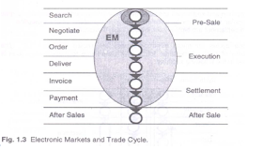

Electronic Data Interchange:-

v It is used for regular repeat transactions.
v It takes quite a lot of work to set up systems.
v Mature use of EDI allows for a change in the nature of the product or service.
e.g. Applications are sending test results from the pathology laboratory to the hospital or dispatching exam results from exam boards to school.

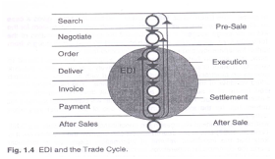

Internet Commerce:-

The first stage
• Advertising appropriate goods and services.
• Internet sites offer only information & any further steps down the trade cycle are conducted on the telephone.
The Second stage

• An increasing no. of sites offer facilities to execute & settle the transaction.
• Delivery may be electronic or by home delivery depending on the goods and services.

The final stage

• After-sales service.
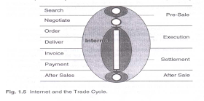
• On-line support & On-Line services.

